Record No: 0562
SIR THOMAS WEBB
6th Bt.

2ND husband of Martha Matilda Somerville (0561).

Birth:
Marriage: 11 July 1821, the British Embassy, Paris. Martha Matilda Hamilton (nee Somerville)
Death:

Notes: Somerville index states that Sir Thomas Webb was of Old Stock, Wiltshire.
www.thepeerage.com says that Sir Thomas Webb was the son of Joseph Webb
of Odstock. Thomas’s sister Anne, born 14 Feb 1763, married Anthomy James Radclyffe, 5th Earl of Newburgh. She died 3 Aug 1861 aged 98.

Source: Somerville Index.

Additional Research:

Sir Thomas Webb, 6th Bt.¹

Sir Thomas Webb, 6th Bt. is the son of Joseph Webb. He married Martha Matilda Somerville, daughter of Sir Quaile Somerville, 2nd Bt. and Sarah Towers, on 11 July 1821 at British Embassy, Paris, France.¹
Sir Thomas Webb, 6th Bt. gained the title of 6th Baronet Webb.¹

Citations
- G.E. Cokayne; with Vicary Gibbs, H.A. Doubleday, Geoffrey H. White, Duncan Warrand and Lord Howard de Walden, editors, The Complete Peerage of England, Scotland, Ireland, Great Britain and the United Kingdom, Extant, Extinct or Dormant, new ed., 13 volumes in 14 (1910-1959; reprint in 6 volumes, Gloucester, U.K.: Alan Sutton Publishing, 2000), volume II, page 268. Hereinafter cited as The Complete Peerage.
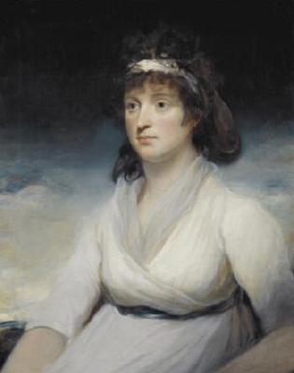
Anne, Countess of Newburgh, sister of Sir Thomas Webb.
http://www.thepeerage.com/p7899.htm#i78984

